**ril.**

**EVALUATION OF ORGANIC INSECTICIDES DERIVED FROM CHILI PEPPERS (*Capsicum frutescens)* FOR COCKROACH CONTROL: FORMULATION AND EFFICACY**

A Quantitative Research Presented to

the Faculty of Senior High School Department

King Thomas Learning Academy, Inc.

Malubago, Sipocot, Camarines Sur.

In partial fulfillment of the requirements for the

subject Practical Research II

Science, Technology, Engineering, and Mathematics

**Delos Santos, Bianca Hazel M.**

**Espiritu, Jorelle Jhade E.**

**Francisco, Francine Lian J.**

**Morillo, Aira D.**

**Pacon, Cristal Ann V.**

**Sulit, Lawrence C.**

December 2024

**CERTIFICATE OF APPROVAL**

The research paper attached hereto, titled **“EVALUATION OF ORGANIC INSECTICIDES DERIVED FROM CHI222LI PEPPERS (*Capsicum frutescens)* FOR COCKROACH CONTROL: FORMULATION AND EFFICACY”** prepared and submitted by **Delos Santos, Bianca Hazel M., Espiritu, Jorelle Jhade E., Francisco, Francine Lian J., Morillo, Aira D., Pacon, Cristal Ann V.,** and **Sulit, Lawrence C.** In partial fulfillment for the subject Practical Research II - Science, Technology, Engineering, and Mathematics is hereby accepted and approved by the Board of Panel whose signature appears below.











**ACKNOWLEDGMENT**

The researchers would like to sincerely thank the following people for their willingness to help, as well as for their unwavering and continuous support, encouragement, and limited time in order to complete this research.

**Ma'am Rhajean R. Buenaventura,** our Research Adviser, who generously shared her expertise, time, and advice. Our research study journey was significantly shaped by your knowledge and assistance.

**Ma'am Melanie Rose SJ. Reyes,** for her huge assistance with our methodology. Her commitment and wisdom were crucial in elucidating the proportion of our respondents. And to **Sir Gem Erdy D. Camino,** for his expertise and guidance in teaching the researchers the distinction between mortality rate and repellant. We deeply appreciate the guidance and support throughout this study.

**Ma'am Erlinda N. Datinginoo, Ma'am Stephanie T. Huerte, and Ma'am Jessa S. Gabriel,** their willingness to engage with our research topic, provide constructive feedback, and offer useful recommendations has played a key role in strengthening the rigor and relevance of our study.

**Ma'am Stephanie T. Huerte,** Statistician, for sharing her knowledge and helping in the analysis of the data and statistical computations.

**Homeowners,** the research respondents, who committed their time to filling out the offered questionnaires and actively participated in our study.

Thank you, **Almighty God,** for giving the researchers life, blessings, courage, strength, and wisdom, and for also being an inspiration to them throughout trying times.

B.H.M.DS.

J.J.E.E.

F.L.J.F.

A.D.M.

C.A.V.P

L.C.S.

**EVALUATION OF ORGANIC INSECTICIDES DERIVED FROM CHILI PEPPERS (*Capsicum frutescens)* FOR COCKROACH CONTROL: FORMULATION AND EFFICACY**

2024

**ABSTRACT**

This study aimed to determine the evaluation of organic insecticides derived from chili pepper(capsicum frutescens) for cockroach control: formulation and efficacy. This study used a quantitative method in the form of an experimental design to collect data. The data gathered and analyzed using Analysis of Variance (ANOVA), observation sheets and survey questionnaires. The respondents who participated in this study were the 30 selective homeowners from South Centro Sipocot, Camarines Sur., in the school year 2024 - 2025. The organic insecticide was tested at three different concentrations: 25%, 50%, and 75%. These concentrations were prepared to determine their impact on the efficacy of repelling and killing cockroaches. The major findings indicate that organic insecticides derived from chili pepper can be effective as a repellent, though it is designed for cockroach control. The product demonstrates its efficacy in repelling cockroaches, depending on the size of the cockroach and the concentration used. The study further recommends future researchers to concentrate on improving formulations such as adding chili pepper-based insecticides with natural aromatic ingredients that can soften the harsh odors, create more appealing appearance with natural colorants, and by using simple packaging materials but functional with a larger number of respondents to ensure accurate results. They should also look for other potential applications of chili pepper extracts that could be used as a substitute for synthetic chemical insecticides, for not only repelling, but also effectively eliminating cockroaches.

**Keywords:** ***Organic insecticide, Chili pepper (Capsicum frutescens), Cockroach control, Mortality rate, Repellent efficacy, Natural insecticides, Synthetic chemicals, Insecticide efficacy.***

| **TABLE OF CONTENTS** | |
| --- | --- |
| **Preliminaries** | |
| Title Page | 01 |
| Certificate of Approval | 02 |
| Acknowledgment | 03 |
| Abstract | 04 |
| Table of Contents | 05 |
| List of Tables | 08 |
| List of Figures | 09 |
| List of Appendices | 10 |
| **Chapter I. Introduction** | 01 |
| Statement of the Problem | 02 |
| Objectives of the Study | 03 |
| Scope and Limitations | 03 |
| Significance of the Study | 04 |
| **Chapter II. Review of Related Literature and Studies** | 05 |
| Review of Related Literature | 05 |
| Review of Related Studies | 07 |
| Synthesis | 09 |
| Conceptual Paradigm | 16 |
| Theoretical Paradigm | 12 |
| Definition of Terms | 17 |
| Assumptions of the Study | 19 |
| Hypothesis | 19 |
| **Chapter III. Methodology** | 20 |
| Research Design | 20 |
| Research Setting | 20 |
| Respondents | 20 |
| Research Instrument | 21 |
| Validity and Reliability | 21 |
| Data Gathering Procedure | 22 |
| Statistical Treatment | 22 |
| **Chapter IV. Results and Discussion** | 26 |
| Mortality Rate of Organic insecticides derived from chili peppers | 26 |
| Level of Acceptability of Organic insecticides derived from chili peppers at a 25% concentration level in terms of Odor | 28 |
| Level of Acceptability of Organic insecticides derived from chili peppers at a 50% concentration level in terms of Odor | 29 |
| Level of Acceptability of Organic insecticides derived from chili peppers at a 75% concentration level in terms of Odor | 31 |
| Level of Acceptability of Organic insecticides derived from chili peppers at a 25% concentration level in terms of Packaging | 33 |
| Level of Acceptability of Organic insecticides derived from chili peppers at a 50% concentration level in terms of Packaging | 34 |
| Level of Acceptability of Organic insecticides derived from chili peppers at a 75% concentration level in terms of Packaging | 36 |
| Level of Acceptability of Organic insecticides derived from chili peppers at a 25% concentration level in terms of Color | 38 |
| Level of Acceptability of Organic insecticides derived from chili peppers at a 50% concentration level in terms of Color | 40 |
| Level of Acceptability of Organic insecticides derived from chili peppers at a 75% concentration level in terms of Color | 42 |
| Difference between level of acceptability and mortality rate of organic insecticides. | 44 |
| **Chapter V. Summary, Findings, and Conclusions** | 45 |
| **Problem 1.** | 46 |
| **Problem 2.** | 48 |
| **Problem 3.** | 49 |
| **Appendices** | 01 |

pagination:

for preliminary pages, use small roman numerals (i,ii,iii, iv, etc.)

page 1 will start at Chapter I.

|  | **LIST OF TABLES** |  |
| --- | --- | --- |
| **Table 1** | Materials | 23 |
| **Table 2** | Mortality Rate of Organic insecticides derived from chili peppers | 26 |
| **Table 3** | Acceptability of Organic insecticides derived from chili peppers at a 25% concentration level in terms of Odor | 28 |
| **Table 4** | Acceptability of Organic insecticides derived from chili peppers at a 50% concentration level in terms of Odor | 29 |
| **Table 5** | Acceptability of Organic insecticides derived from chili peppers at a 75% concentration level in terms of Odor | 31 |
| **Table 6** | Acceptability of Organic insecticides derived from chili peppers at a 25% concentration level in terms of Packaging | 33 |
| **Table 7** | Acceptability of Organic insecticides derived from chili peppers at a 50% concentration level in terms of Packaging | 34 |
| **Table 8** | Acceptability of Organic insecticides derived from chili peppers at a 75% concentration level in terms of Packaging | 36 |
| **Table 9** | Acceptability of Organic insecticides derived from chili peppers at a 25% concentration level in terms of Color | 38 |
| **Table 10** | Acceptability of Organic insecticides derived from chili peppers at a 50% concentration level in terms of Color | 40 |
| **Table 11** | Acceptability of Organic insecticides derived from chili peppers at a 75% concentration level in terms of Color | 42 |
| **Table 12** | Difference between mortality rate and level of acceptability of organic insecticides. | 44 |

|  | **LIST OF FIGURES** |  |
| --- | --- | --- |
| **Figure 1** | Theoretical Framework | 11 |
| **Figures 2** | Conceptual Framework | 15 |
|  |  |  |
|  |  |  |
|  |  |  |

|  | **LIST OF APPENDICES** |  |
| --- | --- | --- |
| **APPENDIX** |  | |
| **A** | References | 02 |
| **B** | Communication Letters | 05 |
| **C** | Sample Questionnaire | 12 |
| **D** | Statistical Computation | 16 |
| **E** | Documentation | 18 |
| **F** | Curriculum Vitae | 20 |

**CHAPTER I**

**INTRODUCTION**

Every homeowner has their insecticides spray to kill harmful insects like cockroaches. Mostly, these homeowners use synthetic insecticides that are made from toxic substances and chemicals used to control and eliminate insect pests, which threaten agricultural production, spread disease, and cause material damage to our properties. This type of insecticide continues to be the main method of battling insect pests. In this research, we explore the potential of chili pepper as an effective alternative eco-friendly insecticide. Chili peppers are known for their spicy flavor. Chili peppers are well-known around the world and are often used as food additives to provide a hot and pungent taste. The extremely hot or burning sensation of chili peppers is due to the presence of capsaicin which is the primary ingredient in formulating the organic insecticides.

Many studies have indicated the potential ecological damage due to the widespread use of synthetic pesticides (Meyer et al., 2007). Despite its efficacy in eliminating insects, this type of insecticide poses harm to the environment because they are poisonous compounds, and they may adversely affect other organisms besides harmful insects. Inclined to this fact, many researchers consider it a stepping stone for further study about the development of a homemade organic insecticide that can help reduce chemically-produced insecticides. The chili pepper has shown particular potential benefit as a source of organic insecticides. It can be extracted to formulate a natural insecticide to prevent or lessen the negative effect of harmful insects. The active ingredient of chili pepper is capsaicin, the compound responsible for chili heat and irritant effect. According to many reports, capsaicin has broad-spectrum insecticidal activity against many species of insects, making it a potential organic insecticide.

This study aimed to produce an eco-friendly and chemical-free chili pepper-based organic insecticide. It sought to contribute to sustainable and safer cockroach-killing insecticides and lessen the reliance on synthetic insecticides. By using organic insecticide, it offered a sustainable alternative to synthetic chemicals, minimizing negative effects on the environment, ecological balance, and pest population control. If successful, the study could open a new approach to controlling and eliminating harmful insects. The study carried out an experiment formulating Capsicum frutescens insecticides, assessing their effectiveness in controlling and eliminating harmful insect populations, particularly cockroaches, and evaluating their performance compared to conventional insecticides available in the market.

**Statement of the Problem**

This study aimed to produce an eco-friendly and chemical-free chili pepper-based organic insecticide. Specifically, it sought to answer the following questions:

1. What is the mortality rate of organic insecticides derived from chili pepper in different concentrations?

2. What is the level of acceptability of the organic insecticides derived from chili pepper for cockroach control in terms of?

a. Odor

b. Packaging

c. Color

3. Is there a significant difference between the mortality rate and the level of acceptability among different concentration levels?

**Objectives of the Study**

The following objectives guided the study:

1. Identify the mortality rate of organic insecticides derived from chili pepper in different concentrations.

2. Identify the level of acceptability of the organic insecticides derived from chili pepper for cockroach control in terms of.

a. odor

b. packaging

c. color

3. Analyze the difference between the mortality rate and the level of acceptability among different concentration levels.

**Scope and Limitations**

The scope of this study focused on the effectiveness of organic insecticides for cockroach control derived from chili peppers (Capsicum frutescens). The study assessed the insecticidal potential of chili peppers and determined their effectiveness in eliminating insect pests, specifically cockroaches. The insecticide spray was the form of insecticide that the study aimed to produce. The respondents were 30 homeowners from South Centro, Sipocot, Camarines Sur, selected through purposive sampling. The produced chili pepper organic insecticide was tested only on cockroaches. Non-participating insects and individuals not involved in the study were not included in the scope.

The study was limited to specific areas. The organic insecticides produced were not tested on insects other than cockroaches. The study did not cover other forms of insecticides, such as powders, granules, and others. Additionally, the study was limited to homeowners from South Centro, Sipocot, Camarines Sur who did not use insecticides.

**Significance of the Study**

This benefited the following beneficiaries:

**Department of Agriculture (DA).** The purpose of this study is to support the Department of Agriculture in its efforts to promote safer products, including pesticides, by highlighting more environmentally friendly options which help growers and consumers

**Homeowners.** This study will have a significant role to the homeowners as they are the one who are more exposed to this kind of product, this would give them the opportunity to find a product that has less chemicals in it.

**Farmers.** This study will help farmers to determine the effectiveness of chili peppers as  alternative insecticide, and to know if it will help them to save money.

**Environmentalist.** This study aims to help the environmentalists to protect the community, and to lessen the impact or risk of the chemicals in people's life.

**Community.** This study will help the community to reduce the toxic waste using the organic insecticide, to decrease harmful effects to the environment as well as the people in the community.

**Future researcher.**  Students who intend to conduct research on using chili peppers as an alternative insecticide can use this study as a source and a reference.

**CHAPTER II**

**REVIEW OF RELATED LITERATURE AND STUDIES**

This paper introduced and presented a review of related literature and studies bearing upon the present pursuit of knowledge. The clear understanding and ideas procured from this review provided the researchers with useful and worthy insight to support the study.

**Review of Related Literature**

This chapter presented and discussed the reviewed literature that is closely related to the present research. It also presents the related literature, related studies, and synthesis. Furthermore, this provides a concise overview of the research and literature, both domestic and international, that is relevant to these studies.

Tamilselvi (2022) stated that the growing concern for environmental safety and the demand for pesticide residue-free food worldwide have evoked interest in pest management through the use of botanicals, which offers a good alternative to manage the insect pests in an eco-friendly manner. This research was carried out to study the efficiency of botanicals on the aphid population in lablab under an organic production system. Both studies focus on exploring natural, eco-friendly alternatives to chemical pesticides for controlling pests.

UK (2023) stated that Capsaicin, an active ingredient in chili peppers, is used as a repellent for insects, birds, and animals. It targets aphids, loopers, armyworms, spider mites, thrips, leaf miners, and whiteflies. Although not a Highly Hazardous Pesticide (HHP), capsaicin's associated hazards include toxic, harmful, skin irritation, and eye damage. The literature highlights capsaicin's broad insecticidal properties, particularly for pests like aphids, armyworms, and whiteflies. The current study extends this understanding to explore its potential for controlling cockroaches.

Septiati (2022) stated that this study investigates the effectiveness of a mixture of clove flower extract and bay leaf extract in repelling flies and cockroaches in outdoor food processing areas. The research used field experiments with different concentrations and exposure times. Results showed that the mixture of 25%-30% extract with 60 minutes of exposure effectively repels flies by 100% in the outdoor dining area. This suggests that natural ingredients, such as clove flower extract and bay leaf extract, can be used as safer insect repellents, reducing environmental damage and food contamination. Both studies focus on using natural, plant-based ingredients as safer, eco-friendly alternatives to chemical insecticides for pest control..

Based on Jaiswal (2021), the Solanaceae family contains the genus Capsicum, which includes five cultivable species and is an important crop plant: C. annuum, C. Chinense, C. frutescens, C. Baccatum as well as C. pubescens. These species are significant for their food and nutritional components, and their hybridization with other species may yield advantageous genes for qualities that are valuable to the economy, such as fruit shape and disease resistance. Their significance has been highlighted by recent developments in breeding, genomics, and genetics, particularly in tissue culture and genetic transformation. This is connected to the study of evaluating  chili pepper (C. frutescens) as a source for developing natural insecticides, as it confirms the plant's importance beyond culinary uses.

The study of Ramili (2020) uses a randomized design strategy to examine the Organic and Inorganic Contact System between Cayenne Pepper and Pesticide Remainders. In the study, 0.5 ml/l water (K1) of inorganic pesticides was mixed with various doses of organic pesticides to produce capsaicin levels that ranged from 0.078% to 0.080%. In contrast to the interaction at 200 ml/l water (P1), the interaction between organic pesticides at 0 ml/l water (P0) produced the lowest proportion of capsaicin levels. Compared to the organic pesticide interactions at 600 ml/l water (P3) and 0 ml/l water (P1), the interaction at ml/l water (P1) was significantly different. This is directly relevant to the study on chili pepper (C. frutescens) as an organic insecticide for cockroach control, as it suggests that the concentration and formulation of chili pepper extract (capsaicin) may be influenced by how it interacts with other insecticides.

**Review of Related Studies**

Alarcon (2024) stated that the study explores the pesticide potential of chili pepper extract against American cockroaches (Periplaneta americana) using three concentrations: 50%, 75%, and 100%. The results show that an increase in concentration leads to increased effectiveness. The study highlights the potential of chili extract as an organic pesticide, but requires further optimization and assessment of long-term environmental and health implications. This could lead to exploring tabasco pepper extract as a sustainable and safer alternative for cockroach control. This study evaluated chili pepper organic insecticides for cockroach control. Both studies focus on the use of chili pepper extracts as an organic insecticide, specifically targeting cockroaches.

According to Hasyierah (2020) A study on the use of a botanical insecticide containing chili and ginger extracts for controlling brown planthopper (BPH) infestation in paddy fields found that a 40% extract concentration with 72 hours of exposure at 30°C effectively reduced BPH mortality. The mixture's pungent odor and contact toxicity studies also confirmed 100% mortality of BPH. Microscopic analysis revealed increased BPH deformities with higher extract concentration. Both studies explore the use of chili pepper extract as a natural insecticide, with Hasyierah’s research providing valuable insights into the concentration and exposure time that are similarly investigated in the current study.

According to Cari (2019) that the study investigated the insecticidal effect of Green Chili Fruit (Capsicum annuum) and Garlic Bulb (Allium sativum) mixture against American Cockroaches. The extracts were kept constant to determine mortality rates. The experiment involved three concentrations: 100%, 75%, and 50%. The 100% concentration showed 100% mortality, while the 75% concentration had 66.6% and the 50% concentration had 6.7% mortality. The study suggests that the extracts can be used as an alternative insecticide to commercially used products, killing cockroaches within 24 hours. Similarly, the current study evaluates the insecticidal efficacy of chili peppers (C. frutescens), potentially targeting similar biological pathways to control cockroaches.

According to Li (2019) the study examined the insecticidal activity of natural capsaicinoids (NC) and reference ingredients against 14 agricultural insects in both laboratory and field settings. Results showed NC had higher lethal concentrations and weaker relative toxicity than reference ingredients. NC showed impressive control against Aphis gossypii but unimpressive against Ectropis obliqua hypulina and Pieris rapae. Li's study suggests that capsaicin oils could be potent insecticides, which align with the current study, and focus on evaluating chili pepper (C. frutescens) insecticide for cockroach control.

Dougoud (2019) examines that homemade botanical insecticides are popular among subsistence and transitional farmers in low-income countries due to limited commercial pesticide availability. These homemade insecticides contain active ingredients with insecticidal, antifeedant, or repellent properties. However, their efficacy is variable and often lower than synthetic pesticides. Factors affecting the efficacy of homemade botanical insecticides include variation in active ingredient content, concentration in plant material, and preparation process. Those who promote the use of homemade botanical insecticides should communicate these unknowns to farmers who use these products to reduce food production losses. The findings of this study could be useful in our research on organic insecticides from chili peppers for cockroach control. They show how effective chili extracts can be in pest management and offer insights into how they might work.

The study by Gesim (2016) yielded several conclusions based on the summarized findings. It is now possible to derive conclusions based on the hypothesis presented. The natural insecticidal effect of Capsicum annuum pod extract on ants and cockroaches was not fully successful. The results of the experiment, where different formulated concentrations were sprayed, showed a 0% mortality rate in the experimental units. Therefore, it can be concluded that these formulated concentrations had no significant impact on the ants but showed a small degree of effectiveness on the cockroaches. While no mortality occurred in the experimental units, the cockroaches exhibited some changes in condition, and a small percentage of the ants showed signs of weakness. The hypothesis of this study, which stated that "there are no significant differences in the effects of different concentrations of Capsicum annuum pod extract (1:10, 1:20, and 1:30) on the mortality of ants and roaches," was accepted. This indicates that the Capsicum annuum pod extract in various concentrations failed to kill the pest insects. This is relevant to the current study, as it also observed the mortality rate of cockroaches in three different concentrations.

**Synthesis**

The studies by Alarcon (2024), Cari (2019), and Hasyierah (2020) all focus on the chilli pepper extract and its potential to become an insecticide that shows effectiveness across different pests, including American cockroaches and brown planthoppers. All three studies used various concentrations of chilli-based mixtures, finding that the higher the concentration, the higher the possibility of increasing the mortality rates. Alarcon and Cari used chili itself or combination with garlic to target cockroaches, while Hasyierah combined chilli with ginger to control brown planthoppers. These studies highlight that chilli-based organic insecticides as safer, sustainable alternatives to chemical pesticides, while pointing that it's important to do more further research to assure their long-term impacts.

The main difference between UK (2023) and Septiati (2022) lies in their focus, target pests, and outcomes. UK (2023) used chilli peppers as a potential broad-spectrum insect repellent, including its effectiveness for cockroach control, but the study needs more exploration, emphasizing the hazards like toxicity and irritation. However, Septiati (2022) investigates a clove flower and bay leaf extract mixture specially for repelling flies and cockroaches, the study shows 100% fly repellent effectiveness that suggests it as a safer, more eco-friendly, and a good alternative for pest control.

The uniqueness of our study focuses on the formulation and the effect of insecticides in the behavior of cockroaches only. This study has a higher concentration of capsaicin compared to other studies, the active component in chili peppers, causing intense irritation, being unconscious, and even death to the cockroaches. Additionally, the natural origin of this chilli pepper makes it safer, and eco-friendly.





**Theoretical Paradigm**

The study was supported by the following theories, which were connected to the acceptance and effectiveness of evaluating organic insecticides derived from chili peppers (Capsicum frutescens) for cockroach control: formulation and efficacy. These existing theories served as the foundation for the study.

**Green Extraction of Natural Products: Theory** by Shanmugam (2015), Natural products are obtained from plant resources through extraction processes due to their increasing demand in industrial sectors such as the pharmaceutical, cosmetic, and food industries. Green extraction is based on the discovery and design of extraction processes that will reduce energy consumption, allow the use of alternative solvents and renewable natural products, and ensure a safe and high-quality extract. This theory is intended to give an in-depth view of the state-of-the art techniques for the extraction of natural products and the influence of various factors on process performance. Each chapter gives a balanced outline of the process techniques, methods, solvents, safety, and environmental benefits of the extraction of natural products. The principles and fundamentals of each extraction process are addressed, and the factors influencing them are further discussed. It provides the reader with comprehensive information about the fundamentals of green extraction and how to explore this knowledge to maximize the efficiency of the extraction method in order to obtain the quality products intended. This theory also illustrates how natural products can be used as ingredients in different industrial sectors and the successful application of green extraction of natural products in academia as a vector of green teaching and research. The research study is connected to this theory since it also uses a plant extract to produce a natural product, which is organic insecticides, to help keep the environment safe by minimizing the use of chemical-based products.

**The Fundamental Theory of Natural and Biological Control** by Thomson (1955), That biological control and natural control can also be achieved through cultural practices, such as the elimination of standing water and the use of mosquito-resistant plants, to create a less hospitable environment for mosquitoes. These approaches to mosquito control are consistent with the fundamental theory of natural and biological control, which seeks to promote the use of natural systems and processes to regulate pest populations. While repellents are not a direct application of natural and biological control theory, they can be used in conjunction with these approaches to provide an additional layer of protection against mosquito bites. Moreover, according to Maia, M. F., & Moore, S. J. (2011), repellents that are derived from natural sources, such as plant extracts, can also be consistent with the principles of natural and biological control, as they rely on natural compounds to deter mosquitoes rather than synthetic chemicals. By examining and evaluating the use of a natural component for insect pest management and evaluating its practical application, research on capsaicin-based insecticides serves as an excellent example of the concepts of natural and biological control.

**Organic Insect Management in Arboriculture: Theory** by Raupp (2022), Covers methods for managing insect pests in trees using organic approaches. It explores theoretical foundations, practical strategies, and the use of organic pesticides. The theory aims to provide a comprehensive understanding of sustainable and organic pest management in arboriculture. The theory discusses organic farming, which is an approach to farming that is ecologically balanced and sustainable. It stated that Integrated Pest Management (IPM) and the National Organic Program (NOP) share the core principles of sustainability, ecological balance, and minimizing environmental impact. While NOP focuses on methods that integrate cultural, biological, and mechanical practices, IPM applies similar principles in arboriculture, emphasizing prevention, monitoring, and the use of non-chemical methods for pest control. While the theory provides a general understanding of organic insect management in arboriculture, the research focuses on evaluating a specific organic insecticide, contributing to the practical application of the theory.



















**Conceptual Paradigm**

This section showed the conceptual framework of the study on the evaluation of organic insecticides derived from chili peppers (Capsicum Frutescens) for cockroach control: formulation and efficacy. The paradigm served as the guide of researchers in conducting thorough study by following a systematic method consisting of input, process, and output.

**INPUT.** The input includes the mortality rate of the chili pepper insecticide in different concentrations (25%, 50%, and 75%). This also includes the level of acceptability of chili pepper insecticide in terms of odor, packaging, and color, as well as the significant difference between the mortality rate and the level of acceptability among different concentrations.

**PROCESS.** The first step in this process involves collecting all necessary materials and ingredients. Selecting the right type of chili pepper such as the siling labuyo. In addition to the peppers, suitable solvents, such as water, are gathered to extract the active ingredients. Equally important is ensuring that the appropriate laboratory equipment—such as blenders, strainers, and spray bottles—is available, along with personal protective equipment (PPE) for safety. Finally, tools for documentation, whether notebooks or digital devices, should be prepared to accurately record observations throughout the experiment.

With all materials in hand, the next step is to conduct the experiment. This begins with the preparation of the chili extract, where the selected chili peppers are washed and blended with the chosen solvent. After blending, the mixture is strained to remove solid particles, yielding a potent liquid insecticide. Once the extract is prepared, it is poured in a spray bottle.

Following the experimenting phase, a detailed efficacy testing of the chili insecticide product is essential. Efficacy testing is performed, assessing the insecticide against the cockroach to determine its effectiveness, including observing mortality rates among cockroaches exposed to the treatment.

To further enrich the evaluation, conducting surveys and gathering data is important. This begins with designing a structured questionnaire aimed at assessing user experiences with the chili insecticide, focusing on aspects such as its odor, packaging, and color. The survey is then distributed to the selected respondents to ensure a diverse range of opinions. Once the data is collected, it is compiled to analyze common themes in user experiences.

Quantitative analysis follows the data collection phase, involving statistical examination to draw meaningful conclusions. Data from both observation and survey is entered into statistical treatment for analysis. Appropriate statistical tests, such as Weighted Mean and ANOVA, are applied to determine the significance of the results obtained from the observation and survey.

The final step includes the findings, conclusion, and recommendations. The findings present the main data and outcomes discovered through research or analysis. The conclusion interprets the findings and discusses their significance in the context of the research question. The recommendations offer specific suggestions based on the findings and conclusions, and identify areas for further study or exploration to build on the current work.

**OUTPUT.** The output shows the results of the mortality rate and the level of acceptability of the chili pepper insecticide, as well as their differences.

**Definition of Terms**

**Alternative Insecticide.** This term refers to an insecticide that employs a different strategy or technique than conventional pesticides. In this study, it is defined as the insecticide that is used as a substitute for traditional chemical-based insecticides, often derived from natural sources.

**Broad-spectrum insecticidal activity.** This refers to the capacity of an insecticide to efficiently target and eradicate a broad spectrum of bug species. In this study, it refers to the ability of the chili pepper as an insecticide to target and affect a wide range of insect pests.

***Capsaicin.*** This word refers to a chemical component that gives chili peppers their fiery flavor and irritating properties. In this study, it is the active compound found in chili peppers (Capsicum frutescens) that provides the basis for the insecticide.

***Capsicum frutescens.*** Is one of the species of chili pepper. In this study, it serves as the scientific name of chili pepper used in this study.

**Chemical-free.** The term excludes synthetic or artificial substances. In this study, it is an attribute of the chili pepper insecticides that indicates they do not contain synthetic chemicals or are derived from natural sources without the addition of synthetic chemicals.

**Chili pepper.** A small, hot-tasting pod of a variety of capsicum. In this study, it serves as the source of capsaicin, which is the active compound being studied for its insecticidal properties.

**Cockroach.** This served as the subject to test and determine how well the insecticide spray worked.

**Eco-friendly Insecticide.** It refers to a pesticide made with sustainability and the environment's minimal impact in mind. In this study, it refers to the chile pepper insecticide designed to have minimal impact on the environment, often made from natural or biodegradable substances.

**Pest Population Control.** Means controlling insect populations to avoid harming crops, property, or people's health. In this study, it is defined as the process of reduction or management of insect pest numbers through the use of organic insecticides.

**Synthetic Insecticides.** It is defined as insecticides made using chemicals, which can have harmful ingredients. In this study, it is defined as an insecticide that is chemically manufactured and a product that this study gives an alternative to.

**Toxic Substances.** This term refers to substances or items with the potential to harm living things. In this study, it is a compound that is harmful or poisonous to living organisms, which can be present in some insecticides.

**Assumption of the Study**

The following assumptions provide a lens through which we view the research questions and guide our approach to data collection and analysis of our study.

1. The chili pepper organic insecticide can effectively kill cockroaches.
2. The chili pepper organic insecticide has a strong smell.
3. The level of effectiveness of chili pepper organic insecticide may vary.

**Hypothesis**

The hypothesis will serve as the focal point around which data will be collected, analyzed, and interpreted, with the goal of drawing well-founded conclusions and expanding knowledge in this study.

There is no significant difference between the mortality rate and the level of acceptability of organic insecticide derived from Chili Peppers (C. frutescens) for cockroach control.

**CHAPTER III**

**METHODOLOGY**

This chapter describes the study's research design and instrument additionally, it contains the respondents, research setting, data-gathering procedure, statistical treatment, and more information and understanding.

**Research Design**

The study used a quantitative method in the form of an experimental design to collect data. Experimental research design employs a scientific approach to provide evidence for the study. The study involved evaluating the efficacy of organic insecticides by creating and testing various concentrations to determine how well they control cockroach populations.

**Research Setting**

The product experiment was conducted at one of the researcher’s locations in Zone 3 Acucena, Sipocot, Camarines Sur, that is 2.5 kilometers riding a tricycle from King Thomas Learning Academy Inc. The survey took place in South Centro, Sipocot, Camarines Sur as well, where the 30 selected respondents are located. The researchers chose these study settings to help achieve the study's goals and purposes, specifically to investigate the effectiveness and acceptability of the chili pepper insecticides.

**Research Respondents**

The respondents in this study were the 30 selected homeowners from South Centro, Sipocot, Camarines Sur, who use insecticides at home. Thirty (30) respondents participated by answering the observation sheet. The 30 selected respondents from South Centro, Sipocot, Camarines Sur, were chosen through purposive sampling. These types of respondents and sampling techniques were selected to provide more valuable data and insights, enhance the validity and reliability of the study, and avoid bias.

**Research Instrument**

In this study, observation sheets and survey questionnaires served as the major research instruments. The observation sheet was used to record the detailed data about behaviors or conditions as they occur in real-time. The survey questionnaire contains a close-ended question related to the research topic and was used to evaluate the level of acceptability of the chili insecticides in terms of odor, packaging, and color. These instruments were completed by the researchers and the 30 selected respondents from South Centro, Sipocot, Camarines Sur. This strategy simplified the data collection, reduced response variability, and improved the reliability and validity of the findings. It made the collection of data more efficient and ensured that the information gathered was accurate and reliable.

**Validity and Reliability**

To ensure the validity and reliability of the study, the researchers evaluated the effectiveness of chili peppers against cockroaches using an observation sheet to determine the mortality rate of the insects. This method allowed for the collection of important and relevant data. Additionally, the researchers developed a survey questionnaire to be distributed to 30 selected homeowners in South Centro, Sipocot, Camarines Sur. To guarantee the accuracy and precision of the questionnaire and observation sheet, the researchers consulted their research adviser and panelists, ensuring the study's validity. Furthermore, science teachers at King Thomas Learning Academy, Inc. were consulted and given a direct presentation of the study to enhance their understanding. The researchers also focused on ensuring the study's reliability by using dependable instruments and maintaining consistency, which contributed to meaningful and successful results.

**Statistical Treatment**

**Frequency and Percentage Distribution** were used to determine how many cockroaches died in each trial and to calculate the percentage of cockroaches that died at each concentration level (25%, 50%, 75%). The mortality rate of chili pepper as an organic insecticide at different concentrations, as well as the level of acceptability, were evaluated using **Weighted Mean and Ranking Technique.** Furthermore, **Analysis of Variance (ANOVA)** was used to determine whether there is a significant difference between the mortality rate and the level of acceptability of the produced chili pepper organic insecticide. This statistical treatment helped to identify and understand the significant relationship between the mortality rate and the acceptability of the chili pepper insecticide, thereby providing support for the conclusions and insights gathered from the study.

**Data Gathering Procedure**

In the data-gathering procedure, the researchers began by collecting all the materials needed for the experiment, including the chili peppers. They first measured 50g, then 100g, and finally 150g of raw chili peppers using a digital scale. After obtaining these measurements, the researchers prepared three spray bottles, each containing 100 ml of water. The three measurements of chili peppers were processed one by one in the blender along with 100 ml of water, resulting in a liquid substance. After blending the chili peppers, the researchers strained the mixture to remove the solid matter from the chili pepper peels. The three measurements of blended chili peppers were separately added to each spray bottle, creating three insecticide sprays with different concentration levels (25%, 50%, and 75%). The chili pepper organic insecticides were then ready for testing. Next, the researchers gathered and collected cockroaches to test the organic insecticides they had produced. Each researcher diligently caught cockroaches from their homes and brought them together for the study. The insecticides were applied to the cockroaches, and after waiting for 4 minutes, the researchers checked the mortality rate of the cockroaches. The researchers then prepared to conduct a survey with their respondents. The survey was conducted at South Centro, Sipocot, Camarines Sur, where 30 selected homeowners were surveyed. The researchers distributed the survey questionnaires, which had been approved by their thesis adviser, and collected them after the respondents completed them. The respondents were selected through purposive sampling. After collecting all the data, the researchers recorded and submitted the data for statistical treatment.

**Table 1. The following are the materials or ingredients with its quantities and used that the researchers will be using in their study:**

| Materials/Ingredients | Quantity | Use/s |
| --- | --- | --- |
| Mask | As many as needed | This will be used to cover up the nose, since the chili has the component of capsaicin that has a strong smell that can irritate the nose. |
| Gloves | As many as needed | It will be used for protection for the hands for any contact with the chili. |
| PPE | 1 only | This will be used to protect the researcher from the irritating effect of chili. |
| Strainer | 1 piece | This will be used to strain or separate the solid parts of the chili. |
| Blender | 1 piece | This will be used to turn chili pepper into liquid. |
| Spoon | 1 piece | It will be used to stir the components. |
| Timer | 3 pieces | This will be used to calculate the duration of the cockroach exposure to the spray. |
| Bottle Spray | 3 pieces | It will be used to apply the researchers' organic pesticide. |
| Small Plastic Container | 9 pieces | This will be used to place the cockroach that will be used by the researchers. |
| Digital Scale | 1 only | This will be used to measure the weight of chili pepper in grams. |
| Water | 300 ml | It will be used as one of the product components of the researchers. |
| Chili Pepper | 300 grams | It will be used as one of the product components of the researchers. |
| Cockroach | 45 cockroach | This served as the subject to test and determine how well the insecticide spray worked. |

**CHAPTER IV**

**RESULTS AND DISCUSSION**

This chapter presented the results and findings, analysis, and interpretation of data gathered by letting the respondents answer the survey checklists. This also includes the data on the concentration level and the level of acceptability of the researcher’s product. Also, finding the results if there is a significant difference between the concentration level and level of acceptability of the organic insecticides derived from chili peppers.

**Table 2. *Mortality Rate of Organic insecticides derived from chili peppers***

| **Trial Intervals** | **Concentration 25%** | **Concentration 50%** | **Concentration**  **75%** |  |
| --- | --- | --- | --- | --- |
| Trial 1 | 1 | 1 | 0 |  |
| Trial 2 | 1 | 2 | 0 |  |
| Trial 3  Total  Percentage | 1  3  20% | 1  4  27% | 0  0  0% |  |

According to Table 2, the outcomes of dead cockroaches indicated that the experiment was ineffective. The insecticides at a 25% concentration level resulted in 3 dead cockroaches out of 15. Within 4 minutes in trial 1, 1 out of 5 cockroaches died, with the same result in trials 2 and 3. The insecticides at a 50% concentration level resulted in 4 dead cockroaches out of 15. In trial 1 at 50%, 1 out of 5 cockroaches died, while in trial 2, 2 out of 5 cockroaches died, and in trial 3, 1 out of 5 cockroaches died. The insecticides at a 75% concentration level resulted in 0 dead cockroaches in all trials out of 15. The total number of dead cockroaches was only 7 out of 45 across all trials. Additionally, the cockroaches used at different concentrations were not the same size. In the 25% concentration, small cockroaches were used, while the 50% concentration included both small and large cockroaches in the same container. The 75% concentration used only large cockroaches.

The percentage of dead cockroaches for each concentration was calculated by adding the number of dead cockroaches in each trial per concentration, dividing by the total number of cockroaches in each trial, and multiplying by 100. The 25% concentration level resulted in 20%, the 50% concentration level resulted in 26.7% or 27%, and the 75% concentration level resulted in 0%. Observations showed that the insecticides did not appear effective, possibly due to insufficient ingredients. However, it was noted that with increasing spray volume, the cockroaches appeared weaker.

The study Organic Insect Management in Arboriculture:Theory by Raupp (2022) focuses on applying these principles to arboriculture, evaluating the effectiveness of organic insecticides in practice. In a related experiment, the effectiveness of an organic insecticide was tested against cockroaches at varying concentration levels. At 25%, the results showed 3 dead cockroaches out of 15 across three trials, translating to a 20% mortality rate. At 50%, there were 4 dead cockroaches, with a mortality rate of 26.7%. At 75%, no cockroaches died, indicating a 0% mortality rate. Variability in cockroach sizes across the concentrations may have influenced the outcomes, while the result suggest limited effectiveness, it was observed that higher exposure weakened the cockroaches, increasing the potential effect. Raupp (2022) provides a theoretical foundation for sustainable pest control, experimental evidence underscores the importance of optimizing formulations and application methods to improve efficacy.

**Table 3. *Acceptability of Organic insecticides derived from chili peppers at a 25% concentration level in terms of Odor***

| **Statement** | **Weighted Mean** | **Rank** | **Interpretation** |
| --- | --- | --- | --- |
| 1. The product has a strong spicy odor. | 3.50 | 1 | Strongly Agree |
| 2. The product has a pleasant odor. | 2.73 | 5 | Agree |
| 3. The product has a mild odor. | 2.46 | 8 | Disagree |
| 4. The product has a distinctive scent. | 3.00 | 3 | Agree |
| 5. The product has a fresh herbal smell. | 2.70 | 6 | Agree |
| 6. The product has a strong chemical odor. | 2.36 | 9 | Disagree |
| 7. The product has an unpleasant odor. | 2.56 | 7 | Agree |
| 8. The product has a lingering odor. | 2.76 | 4 | Agree |
| 9. The product has an overpowering scent that can be off-putting for users with sensitivities or allergies. | 3.10 | 2 | Agree |
| 10. The product has a foul odor. | 2.40 | 10 | Disagree |
| **Average Weighted Mean** | **2.75** |  | **Agree** |

Legend:

*Strongly Agree (3.26 - 4.00), Agree (2.51 - 3.25), Disagree (1.76 - 2.50), and Strongly Disagree (1.00 - 1.75)*

According to Table 3, the results of the data in terms of odor showed that the chili pepper insecticide with a 25% concentration level had an average mean of 2.75, which was labeled as "agree." Statement 4 ranked 3 with a weighted mean of 3, which was also labeled as "agree." This indicated that the chili pepper insecticide with a 25% concentration had a distinctive odor, unique and unusual compared to regular insecticides. Statement 9 ranked 2 with a weighted mean of 3.1, which was labeled as "agree." This indicated that the chili pepper insecticide with a 25% concentration had an overpowering odor, which may have been off-putting to users with sensitive noses or allergies. This statement highlighted a potential downside of the product, specifically its strong fragrance, which may have been unpleasant or harmful to individuals sensitive to scents or with allergies. Statement 1 ranked 1 with a weighted mean of 3.5, which was labeled as "strongly agree." This indicated that the chili pepper insecticide with a 25% concentration had a strong spicy odor, with most respondents acknowledging its intensity. According to Tamilselvi (2022), chili extract, a non-toxic and environmentally friendly alternative to chemical pesticides, effectively reduced aphid populations and inflorescence infestations in organic lablab cultivation. The chili pepper insecticide with a 25% concentration in this study had a strong spicy odor, which was widely recognized by respondents for its intensity. Additionally, it was considered eco-friendly, as the 25% concentration's odor was not overpowering enough to negatively impact people's sense of smell.

**Table 4. *Acceptability of Organic insecticides derived from chili peppers at a 50% concentration level in terms of Odor***

| **Statement** | **Weighted Mean** | **Rank** | **Interpretation** |
| --- | --- | --- | --- |
| 1. The product has a strong spicy odor. | 3.40 | 1 | Strongly Agree |
| 2. The product has a pleasant odor. | 2.40 | 9 | Disagree |
| 3. The product has a mild odor. | 2.50 | 7.5 | Disagree |
| 4. The product has a distinctive scent. | 2.90 | 5 | Agree |
| 5. The product has a fresh herbal smell. | 2.50 | 7.5 | Disagree |
| 6. The product has a strong chemical odor. | 2.03 | 10 | Disagree |
| 7. The product has an unpleasant odor. | 2.96 | 4 | Agree |
| 8. The product has a lingering odor. | 3.00 | 2.5 | Agree |
| 9. The product has an overpowering scent that can be off-putting for users with sensitivities or allergies. | 3.00 | 2.5 | Agree |
| 10. The product has a foul odor. | 2.56 | 6 | Agree |
| **Average Weighted Mean** | **2.72** |  | **Agree** |

Legend:

*Strongly Agree (3.26 - 4.00), Agree (2.51 - 3.25), Disagree (1.76 - 2.50), and Strongly Disagree (1.00 - 1.75)*

Table 4 showed that the odor results for the chili pepper insecticide at a 50% concentration level yielded an average mean of 2.72, which was labeled as "agree." According to the table, Statement 7, ranked 3 and labeled as "agree," had a weighted mean score of 2.96, indicating that the odor of the chili pepper insecticide with a 50% concentration was unpleasant. Statements 8 and 9 were both ranked 2.5 and labeled as "agree," with a weighted mean score of 3. This indicated that the chili pepper insecticides with a 50% concentration had a lingering and overpowering scent, which may have been off-putting to consumers with allergies or sensitive noses. Statement 1 received a "strongly agree" rating with a rank of 1 and a weighted mean score of 3.4. This indicated that the chili pepper insecticide with a 50% concentration had a strong spicy odor, with most respondents acknowledging its intensity. According to Li, (2019), the intense heat or burning sensation in chili peppers was caused by capsaicinoids, a unique compound in the capsicum genus, biosynthesized in the fruit's placenta. In this study, the chili pepper insecticide with a 50% concentration was found to have a strong spicy odor, likely due to the hot or burning sensation caused by the capsaicinoids. This sensation was acknowledged by most respondents, contributing to their recognition of the odor's intensity.

**Table 5. *Acceptability of Organic insecticides derived from chili peppers at a 75% concentration level in terms of Odor***

| **Statement** | **Weighted Mean** | **Rank** | **Interpretation** |
| --- | --- | --- | --- |
| 1. The product has a strong spicy odor. | 3.60 | 1 | Strongly Agree |
| 2. The product has a pleasant odor. | 2.56 | 6.5 | Agree |
| 3. The product has a mild odor. | 2.53 | 8 | Agree |
| 4. The product has a distinctive scent. | 2.93 | 5 | Agree |
| 5. The product has a fresh herbal smell. | 2.20 | 10 | Disagree |
| 6. The product has a strong chemical odor. | 2.16 | 9 | Disagree |
| 7. The product has an unpleasant odor. | 3.00 | 4 | Agree |
| 8. The product has a lingering odor. | 3.16 | 3 | Agree |
| 9. The product has an overpowering scent that can be off-putting for users with sensitivities or allergies. | 3.23 | 2 | Agree |
| 10. The product has a foul odor. | 2.56 | 6.5 | Agree |
| **Average Weighted Mean** | **2.79** |  | **Agree** |

Legend:

*Strongly Agree (3.26 - 4.00), Agree (2.51 - 3.25), Disagree (1.76 - 2.50), and Strongly Disagree (1.00 - 1.75)*

According to Table 5, the results of the data in terms of odor showed that the chili pepper insecticide with a 75% concentration level had an average mean of 2.79, which was labeled as "agree." Statement 8 ranked 3 with a weighted mean of 3.16, labeled as "agree." This indicated that the chili pepper insecticide with a 75% concentration had a lingering odor, meaning the strong smell persisted for a period of time after application. Statement 9 ranked 2 with a weighted mean of 3.23, labeled as "agree." This indicated that the chili pepper insecticide with a 75% concentration had an overpowering odor, which may have been off-putting to users with sensitive noses or allergies. This highlighted a potential downside of the product—its strong odor may have been unpleasant or harmful to individuals sensitive to scents or with allergies. Statement 1 ranked 1 with a weighted mean of 3.6, labeled as "strongly agree." This indicated that the chili pepper insecticide with a 75% concentration had a strong spicy odor, with most respondents acknowledging its intensity. The study by Septiati (2022) focused on adding natural ingredients as a safer insect repellent. While odor may have contributed to its effectiveness in repelling pests, it also posed a challenge for users sensitive to strong smells or with allergies, potentially limiting its broader application. By analyzing both studies, it became clear that while odor could enhance the repellent effect of natural pest control agents, it could also be a drawback for user experience. This relationship underscored the need for balancing effectiveness with odor intensity, possibly by combining extracts like clove flower and bay leaf with chili pepper to mitigate the strong odor while maintaining pest-repellent efficacy.

**Table 6. *Acceptability of Organic insecticides derived from chili peppers at a 25% concentration level in terms of Packaging***

| **Statement** | **Weighted Mean** | **Rank** | **Interpretation** |
| --- | --- | --- | --- |
| 1. The product's packaging is eco-friendly. | 2.93 | 3 | Agree |
| 2. The packaging has clear labeling. | 2.90 | 4 | Agree |
| 3. The packaging is durable. | 3.36 | 1 | Strongly Agree |
| 4. The packaging is user-friendly. | 3.16 | 2 | Agree |
| 5. The packaging is presentable and attractive. | 2.83 | 6 | Agree |
| 6. The packaging is non-recyclable. | 2.23 | 9 | Disagree |
| 7. The packaging is poorly designed that leads to spills and waste during use. | 2.56 | 8 | Agree |
| 8. The packaging lacks clear information on the label. | 2.60 | 7 | Agree |
| 9. The packaging lacks aesthetic appeal. | 2.86 | 5 | Agree |
| 10. The packaging is difficult to open and use. | 1.90 | 10 | Disagree |
| **Average Weighted Mean** | **2.73** |  | **Agree** |

Legend:

*Strongly Agree (3.26 - 4.00), Agree (2.51 - 3.25), Disagree (1.76 - 2.50), and Strongly Disagree (1.00 - 1.75)*

Table 6, based on the data gathered from the respondents regarding the packaging of the chili pepper insecticide with a 25% concentration, showed an average weighted mean of 2.73, which was labeled as "agree." Statement 1 ranked 3 with a weighted mean of 2.93, labeled as "agree." This indicated that the packaging of the chili pepper insecticide with a 25% concentration was eco-friendly, likely involving the use of recyclable and sustainably sourced materials. Statement 4 ranked 2 with a weighted mean of 3.16, labeled as "agree." This indicated that the packaging of the chili pepper insecticide with a 25% concentration was user-friendly, meaning it was convenient and easy to spray or apply, making it accessible and efficient for the user. Statement 3 ranked 1 with a weighted mean of 3.36, labeled as "strongly agree." This indicated that the packaging of the chili pepper insecticide with a 25% concentration was durable, meaning the container or material used was strong and resistant to damage during handling, storage, and use. Tamilselvi (2022) emphasized the need for environmentally safe pest management solutions, such as botanicals, to promote sustainable farming and reduce pesticide residues. Similarly, the analysis of chili pepper insecticide packaging highlighted its eco-friendly, user-friendly, and durable designs. Both studies underlined the importance of creating products that were not only environmentally responsible but also practical and efficient for consumers, ensuring broader adoption in sustainable agricultural systems.

**Table 7. *Acceptability of Organic insecticides derived from chili peppers at a 50% concentration level in terms of Packaging***

| **Statement** | **Weighted Mean** | **Rank** | **Interpretation** |
| --- | --- | --- | --- |
| 1. The product's packaging is eco-friendly. | 3.00 | 3 | Agree |
| 2. The packaging has clear labeling. | 2.99 | 4 | Agree |
| 3. The packaging is durable. | 3.36 | 1 | Strongly Agree |
| 4. The packaging is user-friendly. | 3.23 | 2 | Agree |
| 5. The packaging is presentable and attractive. | 2.76 | 5 | Agree |
| 6. The packaging is non-recyclable. | 2.33 | 9 | Disagree |
| 7. The packaging is poorly designed that leads to spills and waste during use. | 2.56 | 7 | Agree |
| 8. The packaging lacks clear information on the label. | 2.63 | 6 | Agree |
| 9. The packaging lacks aesthetic appeal. | 2.43 | 8 | Disagree |
| 10. The packaging is difficult to open and use. | 1.93 | 10 | Disagree |
| **Average Weighted Mean** | **2.71** |  | **Agree** |

Legend:

*Strongly Agree (3.26 - 4.00), Agree (2.51 - 3.25), Disagree (1.76 - 2.50), and Strongly Disagree (1.00 - 1.75)*

Based on Table 7, the packaging of organic insecticides derived from chili peppers at a 50% concentration level had an average mean of 2.71, which was labeled as "agree." Statement 1 ranked 3 with a weighted mean of 3, labeled as "agree." This indicated that the packaging of chili pepper insecticide with a 50% concentration was eco-friendly, likely involving the use of recyclable and sustainably sourced materials. Statement 4 ranked 2 with a weighted mean of 3.23, labeled as "agree." This indicated that the packaging of chili pepper insecticide with a 50% concentration was user-friendly, meaning it was convenient and easier to spray or apply, making it more accessible and efficient for the user. Statement 3 ranked 1 with a weighted mean of 3.36, labeled as "strongly agree." This indicated that the respondents overwhelmingly agreed that the packaging of chili pepper insecticide with a 50% concentration was durable, meaning the container or material used was strong and resistant to damage during handling, storage, and use. Tamilselvi (2022) highlights the growing global concern for environmental safety and pesticide residue-free food, leading to a growing interest in pest management through botanicals. The study explores the use of botanicals as eco-friendly alternatives to control insect pests, particularly aphids in lablab under organic production systems. The research also highlights the trend towards sustainable pest control, particularly using organic insecticides derived from chili peppers. The findings suggest that chili pepper insecticide packaging, especially at a 50% concentration, aligns with eco-friendly principles, demonstrating a shared commitment to reducing reliance on chemical pesticides and fostering sustainability in agricultural practices.

**Table 8. *Acceptability of Organic insecticides derived from chili peppers at a 75% concentration level in terms of Packaging***

| **Statement** | **Weighted Mean** | **Rank** | **Interpretation** |
| --- | --- | --- | --- |
| 1. The product's packaging is eco-friendly. | 3.00 | 4.5 | Agree |
| 2. The packaging has clear labeling. | 3.06 | 3 | Agree |
| 3. The packaging is durable. | 3.10 | 2 | Agree |
| 4. The packaging is user-friendly. | 3.23 | 1 | Agree |
| 5. The packaging is presentable and attractive. | 3.00 | 4.5 | Agree |
| 6. The packaging is non-recyclable. | 2.20 | 9 | Disagree |
| 7. The packaging is poorly designed that leads to spills and waste during use. | 2.46 | 7 | Disagree |
| 8. The packaging lacks clear information on the label. | 2.43 | 8 | Disagree |
| 9. The packaging lacks aesthetic appeal. | 2.63 | 6 | Agree |
| 10. The packaging is difficult to open and use. | 2.16 | 10 | Disagree |
| **Average Weighted Mean** | **2.72** |  | **Agree** |

Legend:

*Strongly Agree (3.26 - 4.00), Agree (2.51 - 3.25), Disagree (1.76 - 2.50), and Strongly Disagree (1.00 - 1.75)*

Table 8, based on the data gathered from the respondents regarding the packaging of the chili pepper insecticide with a 75% concentration, showed an average weighted mean of 2.72, which was labeled as "agree." Statement 2 ranked 3 with a weighted mean of 3.06, labeled as "agree." This indicated that the packaging of the chili pepper insecticide with a 75% concentration had clear labeling. This could have referred to instructions for use, safety precautions, ingredients, and any warnings or necessary information that helped the consumer properly and safely use the product. Statement 3 ranked 2 with a weighted mean of 3.1, also labeled as "agree." This indicated that the packaging of the chili pepper insecticide with a 75% concentration was durable, meaning the container or material used was still strong and resistant to damage during handling, storage, and use. Statement 4 ranked 1 with a weighted mean of 3.23, labeled as "agree." This indicated that the packaging of the chili pepper insecticide with a 75% concentration was user-friendly, meaning it was convenient and easier to spray or apply, making it more accessible and efficient for the user. Both findings emphasized the value of environmentally friendly pest control methods, with Tamilselvi (2022) focusing on the use of botanicals to control pests in an organic production system, while the second study examined consumer perceptions of a chili pepper-based insecticide's packaging. Together, these studies reflected a growing trend toward sustainable and consumer-conscious pest management practices. Both approaches contributed to reducing reliance on chemical pesticides, offering safer, more accessible solutions for pest control.

**Table 9. *Acceptability of Organic insecticides derived from chili peppers at a 25% concentration level in terms of Color***

| **Statement** | **Weighted Mean** | **Rank** | **Interpretation** |
| --- | --- | --- | --- |
| 1. The color of organic chili insecticides is typically orange. | 3.46 | 1 | Strongly Agree |
| 2. The darker the color of the chili insecticides the more effective. | 3.06 | 2 | Agree |
| 3. The color of organic chili insecticides remains consistent over time. | 2.56 | 7 | Agree |
| 4. Organic chili insecticides are generally free from artificial color additives. | 2.66 | 6 | Agree |
| 5. Every concentration produces a different color intensity. | 3.03 | 3 | Agree |
| 6. The color of organic chili insecticides is transparent. | 2.36 | 9 | Disagree |
| 7. The color of organic chili insecticides change over time. | 2.73 | 5 | Agree |
| 8. Every concentration produces the same color intensity. | 2.83 | 4 | Agree |
| 9. The color of the chili insecticides does not have to do with its effectiveness. | 2.43 | 8 | Disagree |
| 10. The color of organic chili insecticides are produced by the use of artificial color additives. | 2.10 | 10 | Disagree |
| **Average Weighted Mean** | **2.72** |  | **Agree** |

Legend:

*Strongly Agree (3.26 - 4.00), Agree (2.51 - 3.25), Disagree (1.76 - 2.50), and Strongly Disagree (1.00 - 1.75)*

The data collected from the respondents about the color of the chili pepper insecticide with a 25% concentration was presented in Table 9, which showed an average weighted mean of 2.72, categorized as "Agree." Statement 5 ranked 3 with a weighted mean of 3.03, also labeled as "Agree." This showed that each concentration produced a different color intensity. The respondents perceived the color intensity differently based on the concentration of the chili pepper insecticide. Statement 2 ranked 2 with a weighted mean of 3.06, labeled as "Agree." This indicated that the darker the color of the chili insecticide, the more effective it was. This could have implied a direct relationship between the darkness of the color and the perceived effectiveness. Statement 1 ranked 1 with a weighted mean of 3.46, labeled as "Strongly Agree." This indicated that the color of organic chili insecticides with a 25% concentration was typically orange. This could have referred to the color of the product itself, perhaps due to the natural ingredients or the chili extract used in its formulation. The UK study (2023) highlighted capsaicin's insecticidal properties against pests like aphids, armyworms, and whiteflies, while also highlighting potential hazards. The study revealed a relationship between the darker color of capsaicin and its perceived effectiveness, suggesting visual characteristics

**Table 10. *Acceptability of Organic insecticides derived from chili peppers at a 50% concentration level in terms of Color***

| **Statement** | **Weighted Mean** | **Rank** | **Interpretation** |
| --- | --- | --- | --- |
| 1. The color of organic chili insecticides is typically orange. | 3.46 | 1 | Strongly Agree |
| 2. The darker the color of the chili insecticides the more effective. | 2.96 | 2 | Agree |
| 3. The color of organic chili insecticides remains consistent over time. | 2.66 | 4.5 | Agree |
| 4. Organic chili insecticides are generally free from artificial color additives. | 2.66 | 4.5 | Agree |
| 5. Every concentration produces a different color intensity. | 2.66 | 4.5 | Agree |
| 6. The color of organic chili insecticides is transparent. | 2.20 | 9.5 | Disagree |
| 7. The color of organic chili insecticides change over time. | 2.46 | 7 | Disagree |
| 8. Every concentration produces the same color intensity. | 2.73 | 3 | Agree |
| 9. The color of the chili insecticides does not have to do with its effectiveness. | 2.20 | 9.5 | Disagree |
| 10. The color of organic chili insecticides are produced by the use of artificial color additives. | 2.43 | 8 | Disagree |
| **Average Weighted Mean** | **2.64** |  | **Agree** |

Legend:

*Strongly Agree (3.26 - 4.00), Agree (2.51 - 3.25), Disagree (1.76 - 2.50), and Strongly Disagree (1.00 - 1.75)*

The results shown in Table 10 indicated that the color of the chili pepper insecticide with a 50% concentration level had an average mean of 2.64, which was labeled as "agree." Statement 8 ranked 3, with a weighted mean of 2.73, labeled as "agree." This implied that every concentration produced the same color intensity, meaning that regardless of the concentration of the chili insecticide, the color intensity remained consistent across different concentrations. Statement 2 ranked 2, with a weighted mean of 2.96, labeled as "agree." This indicated that the darker the color of the chili insecticide, the more effective it was. Some respondents generally believed there was a correlation between the color intensity (darker color) and the effectiveness of the insecticide. Statement 1 ranked 1, with a weighted mean of 3.46, labeled as "strongly agree." This indicated that the color of organic chili insecticides with a 25% concentration was typically orange. This could have referred to the color of the product itself, perhaps due to the natural ingredients or the chili extract used in its formulation. The study of Alarcon (2024) discusses the effectiveness of chili pepper extract as an organic pesticide for controlling cockroaches, highlighting the positive correlation between concentration and effectiveness, as well as the need for further research into its environmental and health implications. It is somehow similar to the current study which concluded that the respondents' views on color intensity and its relationship to effectiveness complement the study's findings on the potential of chili pepper extract as an organic pesticide, underlining the need for continued investigation into its attributes and overall performance in pest control.

**Table 11. *Acceptability of Organic insecticides derived from chili peppers at a 75% concentration level in terms of Color***

| **Statement** | **Weighted Mean** | **Rank** | **Interpretation** |
| --- | --- | --- | --- |
| 1. The color of organic chili insecticides is typically orange. | 3.43 | 1 | Strongly Agree |
| 2. The darker the color of the chili insecticides the more effective. | 3.10 | 2 | Agree |
| 3. The color of organic chili insecticides remains consistent over time. | 2.46 | 7 | Disagree |
| 4. Organic chili insecticides are generally free from artificial color additives. | 2.86 | 3 | Agree |
| 5. Every concentration produces a different color intensity. | 2.56 | 5 | Agree |
| 6. The color of organic chili insecticides is transparent. | 2.23 | 9 | Disagree |
| 7. The color of organic chili insecticides change over time. | 2.53 | 6 | Agree |
| 8. Every concentration produces the same color intensity. | 2.70 | 4 | Agree |
| 9. The color of the chili insecticides does not have to do with its effectiveness. | 2.40 | 8 | Disagree |
| 10. The color of organic chili insecticides are produced by the use of artificial color additives. | 2.06 | 10 | Disagree |
| **Average Weighted Mean** | **2.63** |  | **Agree** |

Legend:

*Strongly Agree (3.26 - 4.00), Agree (2.51 - 3.25), Disagree (1.76 - 2.50), and Strongly Disagree (1.00 - 1.75)*

The data collected from respondents regarding the color of the chili pepper insecticide with a 75% concentration was presented in Table 11, showing an average weighted mean of 2.63, categorized as "Agree." Statement 4 ranked 3 with a weighted mean of 2.86, also labeled as "Agree." This indicated that the chili pepper insecticides with 75% concentration were generally free from artificial color additives, meaning that their color was natural and came from the chili itself. The respondents perceived the color intensity differently based on the concentration of the chili pepper insecticide. Statement 2 ranked 2 with a weighted mean of 3.1, labeled as "Agree." This indicated that the darker the color of the chili insecticide, the more effective it was. Some respondents believed that the darker the color of the chili insecticide, the more effective it was, implying a perceived direct relationship between the darkness of the color and its effectiveness. Statement 1 ranked 1 with a weighted mean of 3.43, labeled as "Strongly Agree." This indicated that the color of organic chili insecticides was typically orange, likely due to the natural ingredients or the chili extract used in its formulation. The study of Alarcon (2024) discusses the effectiveness of chili pepper extract as an organic pesticide for controlling cockroaches, highlighting the positive correlation between concentration and effectiveness, as well as the need for further research into its environmental and health implications. It is somehow similar to the current study which concluded that the respondents' views on color intensity and its relationship to effectiveness complement the study's findings on the potential of chili pepper extract as an organic pesticide, underlining the need for continued investigation into its attributes and overall performance in pest control.

**Table 12. Difference between mortality rate and level of acceptability of organic insecticides.**

| **F-Test Value** | **Between the group** | **Within the group** | **F-critical value a=0.05** | **Decision** | **Interpretation** |  |
| --- | --- | --- | --- | --- | --- | --- |
| 2. 62  2. 62  2. 62 | 5  5  5 | 24  24  24 | 2.67  2.67  2.67 | Failed to reject *Ho*  Failed to reject *Ho*  Failed to reject *Ho* | No Significant Difference  No Significant Difference  No Significant Difference |  |

The data in Table 12 above presented the outcomes derived from the analysis of variance (ANOVA) conducted to assess the difference in mortality rates and the level of acceptability in terms of odor, packaging, and color among different concentrations.

As shown in the table above, the F-test value (2.62) was less than the F-critical value (2.67). Therefore, the decision was to fail to reject the null hypothesis (Ho), meaning there was no evidence to suggest a significant difference in mortality rates and the level of acceptability among different concentrations. This implied that the observed differences between groups or conditions were too small to confidently conclude that they were not due to random chance. The study of Gesim (2016) found that the natural insecticidal effect of Capsicum annuum pod extract did not result in significant mortality in ants and cockroaches, with a 0% mortality rate observed at all tested concentrations. This led to the acceptance of the hypothesis that there would be no significant differences in the effects of varying concentrations on pest mortality. Similarly, the study involving Capsicum frutescens, where the F-test value of 2.62 was lower than the F-critical value of 2.67, leading to the conclusion that there was no significant difference in mortality rates and the level of acceptability across different concentrations. Both studies reached similar conclusions, indicating that neither Capsicum annuum nor Capsicum frutescens extracts had a significant effect on the mortality of the pests under the conditions tested, suggesting that the insecticidal properties of these extracts may not be as potent as expected in pest control.

**CHAPTER V**

**SUMMARY, CONCLUSION, AND RECOMMENDATION**

This chapter presents the summary findings, conclusions, and recommendations of the study. From the findings, conclusions were drawn from which the recommendations were based.

**Summary**

This research study aimed to evaluate the organic insecticides derived from chili peppers (Capsicum frutescens) for cockroach control. The researchers sought to answer the following questions: (1) What was the mortality rate of organic insecticides derived from chili peppers in different concentrations? (2) What was the level of acceptability of the organic insecticides derived from chili pepper for cockroach control in terms of odor, color, and packaging? (3) Was there a significant difference between the mortality rate and the level of acceptability among different concentration levels? This study used a quantitative method in the form of an experimental design to collect data. The total number of selected respondents was thirty (30) homeowners from South Centro, Sipocot, Camarines Sur. The researchers used analysis of variance (ANOVA) to ascertain whether there was a significant difference between the level of mortality rate and level of acceptability of the produced chili pepper organic insecticide. A purposive sampling technique was used to select the population, giving everyone an equal chance of being chosen. The research used statistical methods to analyze and interpret the data to determine the accuracy of the result. A weighted mean was also utilized to calculate and represent the average of the given data.

**Problem 1**

***What is the mortality rate of organic insecticides derived from chili pepper in different concentrations?***

**Findings**

The observation of organic insecticides derived from chili peppers revealed several key findings. In the case of insecticides with a 25% concentration, researchers noted that the cockroaches started to move slower and weaker. Their rapid movements became sluggish, and they struggled to move. Insecticides with a 50% concentration had similar effects as the 25% concentration. As the insecticides were applied, the cockroaches became slower and weaker, and if the exposure time was prolonged, the cockroaches eventually died. At the 75% concentration level, the more insecticide that was sprayed, the more the cockroaches appeared dizzy and weakened. However, if the exposure time was extended further, they regained strength. In summary, the data suggested that the organic insecticides derived from chili peppers had limited effectiveness in the experiment. However, the concentration of the insecticide and the size and type of cockroach may influence its properties and effectiveness.

**Conclusion**

Based on the findings of the study, it was concluded that the chili peppers insecticide did not appear to be effective according to our observations. The researchers also concluded that the ipisticides resulted in the death of 7 out of 45 cockroaches. There was no significant mortality rate among the experimental units, but the cockroaches showed signs of weakness, with a small percentage exhibiting poor condition.

**Recommendation**

This study can be expanded by examining a wider variety of chili species to determine which are most effective at eliminating cockroaches. The amounts of capsaicin or other active ingredients in different chili species may vary, potentially improving their insecticidal effects. Furthermore, mixing chili extracts with other plants or substances that have insecticidal properties could enhance the formulation's effectiveness. Additionally, the researchers recommend using larger containers for the cockroaches and implementing a more rigorous standardization protocol for cockroach size and type when measuring mortality rates.

**Problem 2**

***What is the level of acceptability of the organic insecticides derived from chili pepper for cockroach control in terms of?***

***a. odor***

***b. packaging***

***c. color***

**Findings**

Several important findings were drawn from the data gathered through the survey about the acceptability of organic insecticides derived from chili peppers (Capsicum frutescens). To begin, the odor of the chili pepper insecticide at all concentrations (25%, 50%, and 75%) received a general consensus of "strongly agree" for its strong and spicy scent and "agree" for its overpowering scent, which can be off-putting for users with sensitivities or allergies. Additionally, the 25% concentration showed that the chili pepper insecticide had a distinctive scent, the 50% concentration showed that the product had a lingering and unpleasant odor, and the 75% concentration showed that the product had a lingering odor. The highest mean scores were for the 75% concentration, where respondents strongly agreed that the odor was intense and overpowering. Regarding packaging, all concentrations (25%, 50%, and 75%) were considered durable and user-friendly. Furthermore, the 25% concentration showed that the packaging of the chili pepper insecticide was eco-friendly, the 50% concentration showed that the packaging was eco-friendly as well, and the 75% concentration showed that the packaging had clear labeling. The 25% concentration received the highest score for packaging durability and eco-friendliness. The color of the chili pepper insecticides was consistently recognized as orange across all concentrations (25%, 50%, and 75%), and the darker the color of the chili insecticides, the more effective they were perceived to be. Moreover, the 25% concentration showed that each concentration produced a different color intensity, the 50% concentration showed that all concentrations produced the same color intensity, and the 75% concentration showed that the chili pepper insecticides were generally free from artificial color additives.

**Conclusion**

Based on the findings of the study, it was concluded that the chili pepper insecticide was generally acceptable in terms of odor, packaging, and color across the three different concentrations (25%, 50%, and 75%). However, the strong odor at higher concentrations may be a drawback for sensitive users. The packaging is acceptable as well but still requires some improvement. The color was generally orange, with varying intensities perceived as an indicator of effectiveness.

**Recommendation**

To improve the acceptability of the organic chili pepper insecticides, the researchers suggest reducing the intensity of the scent, particularly for higher concentrations, to make it more tolerable. Future research could explore the addition of aromatic ingredients to mask the strong odor without affecting the heat level. To improve packaging, the researchers recommend enhancing the clarity and information on the labeling for better consumer guidance. A seal should be added to the mouth of the spray bottle to ensure safety, and a more secure spray bottle should be used to prevent leakage. Additionally, investing in a more appealing packaging design could further improve the product's marketability. In terms of color, researchers should consider exploring additional color options to increase appeal and trust while still aligning with the perceived effectiveness of the product.

**Problem 3**

***Is there a significant difference between the mortality rate and the level of acceptability among different concentration levels?***

**Findings**

According to the analyzed data, the F-test values (2.62) are all less than the F-critical value (2.67), meaning the decision is to fail to reject the null hypothesis (Ho). This indicates that the mortality rate is not significantly different from the level of acceptability of the chili pepper (C. frutescens) insecticide.

**Conclusion**

Based on the findings, it shows that the null hypothesis is accepted, so the researcher can conclude that there is no evidence to suggest a significant difference between the mortality rate and the level of acceptability among different concentrations.

**Recommendation**

The findings and conclusion lead the researchers to recommend that further research on this study should involve a larger sample size of respondents to confirm these findings and explore other factors influencing the mortality rate and level of acceptability.

**APPENDICES**

**APPENDIX A**

**REFERENCES**

**References**

Alarcon, J. L. et. al. (2024). *Influence of the Chili Pepper (Capsicum annuum) Extract on American Cockroach (Periplaneta americana).* Applied Entomology and Innovation, 1(1), 15–18. <https://journals.e-palli.com/home/index.php/aei/article/view/2515>

Cari, M., Cahilig. J., et al. (2019). The insecticidal effect of the mixture of green chili (Capsicum annuum) fruit and garlic (Allium sativum) bulb extracts against American cockroaches (Periplaneta americana).

<https://www.herdin.ph/index.php/component/herdin/?view=research&cid=74070>

Dougoud, J. et al. (2019). Efficacy of homemade botanical insecticides based on traditional knowledge. A review. Agron. Sustain. Dev. 39, 37. <https://doi.org/10.1007/s13593-019-0583-1>

Jaiswal, V. et al. (2021). *Genetics, Genomics and Breeding of Chili Pepper Capsicum frutescens L. and Other Capsicum Species.* Advance in Plant Breeding Strategies Vegetable Crops: (9), 59-89. <https://scholar.google.com/scholar?start=20&q=capsicum+frutescens&hl=en&as_sdt=0,5#d=gs_qabs&t=1723896110327&u=%23p%3DkCm0GT2zDEIJ>

Li B, Yang M, Shi R, Ye M. Insecticidal Activity of Natural Capsaicinoids Against Several Agricultural Insects. Natural Product Communications. 2019;14(7).

<https://journals.sagepub.com/doi/10.1177/1934578X19862695>

Ramli, R. et al. (2020). *Analysis of Contact System for Organic and Inorganic Pesticide Residues on Cayenne Pepper (Capsicum annuum).* Budapest International Research in Exact Sciences 2 (4), 509-521.

<https://scholar.archive.org/work/l2w53sf5bfcidc46zh362vkhxy/access/wayback/https://bircu-journal.com/index.php/birex/article/download/1267/pdf>

Raupp, M. J. (2022). *Organic Insect Management in Arboriculture.*

<https://tcimag.tcia.org/training/organic-insect-management-in-arboriculture-theory-practices-and-pesticides/>

Septiati, Y. et al. (2022) Flies (Musca domestica, Calliphora vomitoria, Sarcophadigae) and Cokroaches (Periplaneta americana) Control Based on Botanical Insecticides in Outdoor Food Processing Areas. Open Access Macedonian Journal of Medical Sciences 10(E):1852-1859

<https://www.researchgate.net/publication/366282741_Flies_Musca_domestica_Calliphora_vomitoria_Sarcophadigae_and_Cokroaches_Periplaneta_americana_Control_Based_on_Botanical_Insecticides_in_Outdoor_Food_Processing_Areas>

Shanmugam, V. (2015). *Green Extraction of Natural Products: Theory.*

<https://www.degruyter.com/document/doi/10.1515/gps-2015-0080/html?lang=en>

Tamilselvi, P. et al. (2022). *Efficacy of Capsaicin Rich Botanicals on the Alphid Population in Lablab (Dolichos lablab L.) under Organic Production System.* International Journal of Environment and Climate Change 12 (11), 1297-1303.

<https://doi.org/10.9734/ijecc/2022/v12i1131108>

Thompson, W. R. (1995). *The Fundamental Theory of Natural and Biological Control.*

<https://www.annualreviews.org/content/journals/10.1146/annurev.en.01.010156.002115>

Uk, Cabi. (2023) Chilli pepper extract for the management of insect pests.In PlantwisePlus Knowledge Bank. <https://doi.org/10.1079/pwkb.20198000095>

**APPENDIX B**

**COMMUNICATION LETTER**

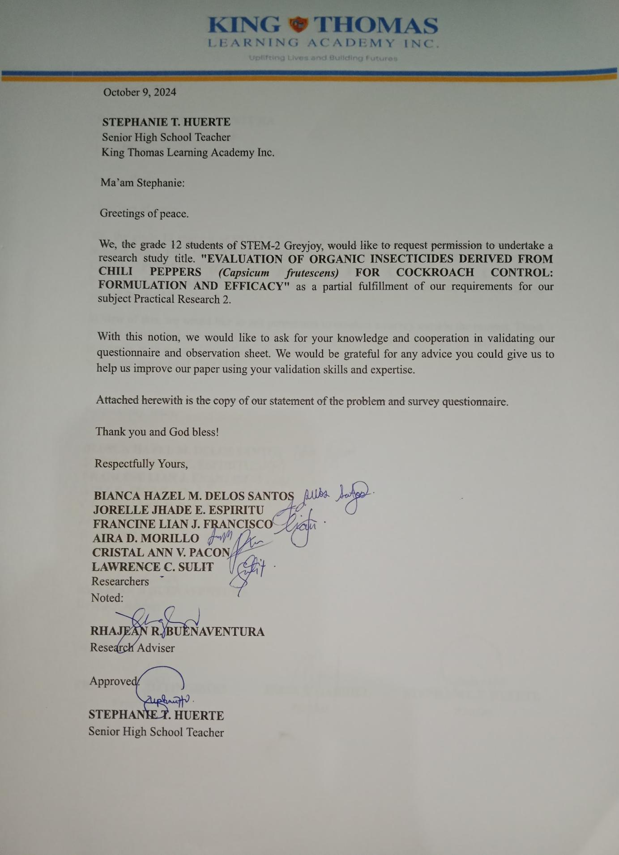

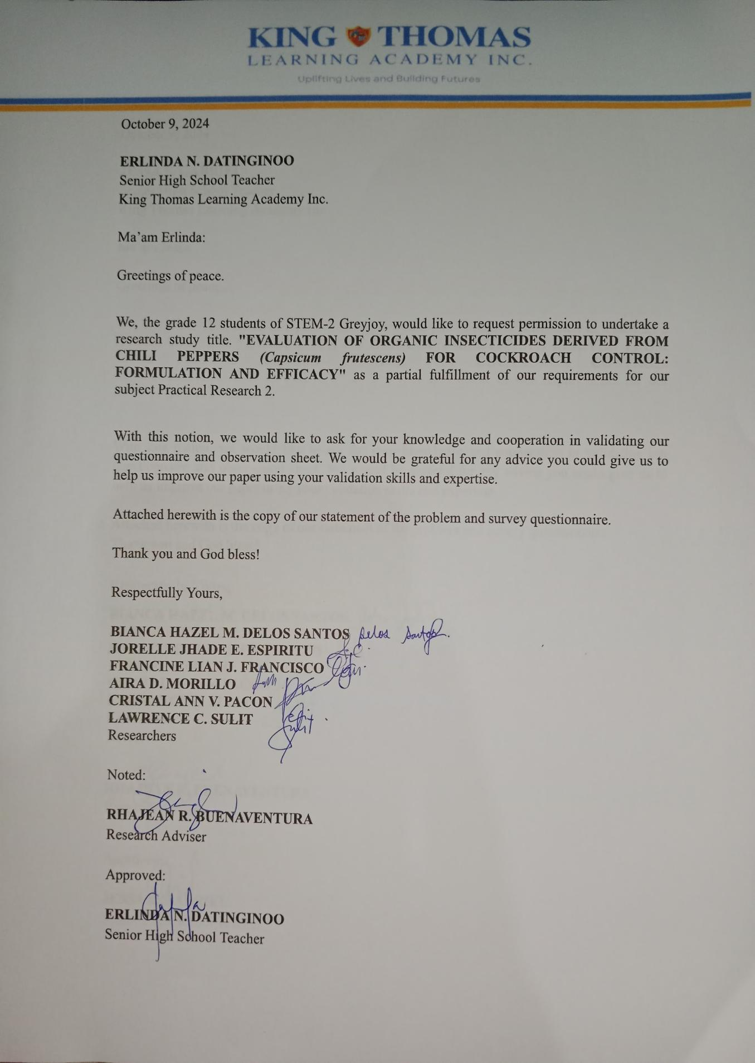



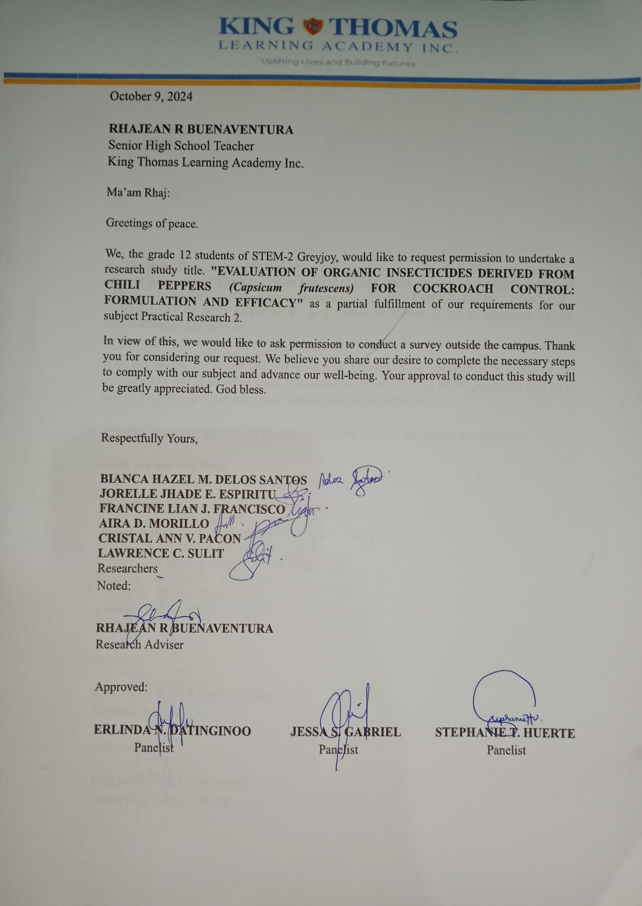

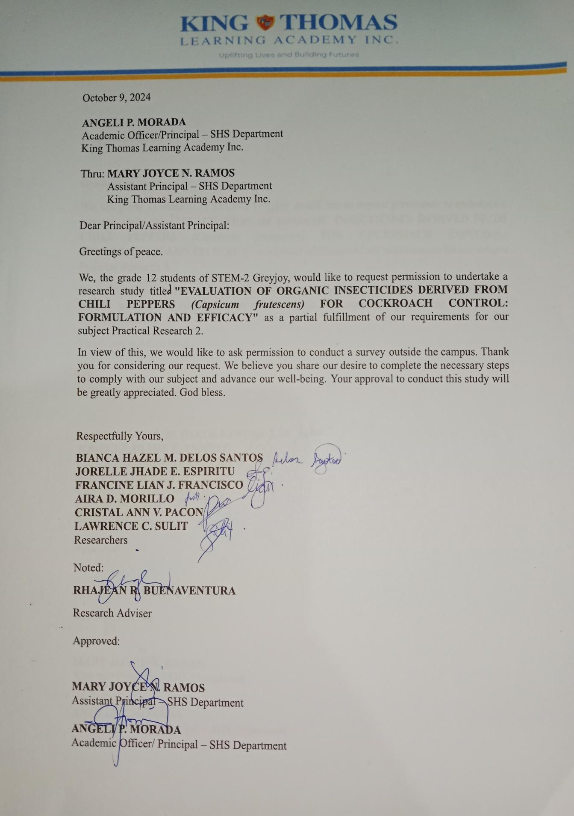



**APPENDIX C**

**SAMPLE QUESTIONNAIRE**

Department of Education 

Region V

King Thomas Learning Academy, Inc.

Malubago, Sipocot, Camarines Sur

**EVALUATION OF ORGANIC INSECTICIDES DERIVED FROM CHILI PEPPERS  (*Capsicum frutescens)* FOR COCKROACH CONTROL: FORMULATION AND EFFICACY**

**QUESTIONNAIRE / OBSERVATION SHEET**

Dear Respondent,

The researchers respect your right to privacy, thus we will not provide anyone access to any of your personal data or unique answers. Your provided data will only be used for research purposes by us.

Respectfully yours,

**————————————————————————————————————**Name (Optional):__________________________  Address:______________________

Direction: Please select (✓) on the given space by completing the questionnaire. Please answer with honesty and accurately. Your response is confidential and will only be known by the researchers.

**Legend:**

(4) - Strongly Agree (2) - Disagree

(3) - Agree (1) - Strongly Disagree

**OBSERVATION SHEET**

| Concentration | Number of dead cockroach after 4 minutes | | | Percentage |
| --- | --- | --- | --- | --- |
| Trial 1 | Trial 2 | Trial 3 |
| 25g |  |  |  |  |
| 50g |  |  |  |  |
| 75g |  |  |  |  |

**QUESTIONNAIRE**

| Odor | | | | |
| --- | --- | --- | --- | --- |
| Characteristics | Strongly Agree | Agree | Disagree | Strongly Disagree |
| 25g/50g/75g | (4) | (3) | (2) | (1) |
| 1. The product has a strong spicy odor. |  |  |  |  |
| 1. The product has a pleasant odor. |  |  |  |  |
| 1. The product has a mild odor. |  |  |  |  |
| 1. The product has a distinctive scent. |  |  |  |  |
| 1. The product has a fresh herbal smell. |  |  |  |  |
| 1. The product has a strong chemical odor. |  |  |  |  |
| 1. The product has an unpleasant odor. |  |  |  |  |
| 1. The product has a lingering odor. |  |  |  |  |
| 1. The product has an overpowering scent that can be off-putting for users with sensitivities or allergies. |  |  |  |  |
| 1. The product has a foul odor. |  |  |  |  |

| Packaging | | | | |
| --- | --- | --- | --- | --- |
| Characteristics | Strongly Agree | Agree | Disagree | Strongly Disagree |
| 25g/50g/75g | (4) | (3) | (2) | (1) |
| 1. The product's packaging is eco-friendly. |  |  |  |  |
| 1. The packaging has clear labeling. |  |  |  |  |
| 1. The packaging is durable. |  |  |  |  |
| 1. The packaging is user-friendly. |  |  |  |  |
| 1. The packaging is presentable and attractive. |  |  |  |  |
| 1. The packaging is non-recyclable. |  |  |  |  |
| 1. The packaging is poorly designed that leads to spills and waste during use. |  |  |  |  |
| 1. The packaging lacks clear information on the label. |  |  |  |  |
| 1. The packaging lacks aesthetic appeal. |  |  |  |  |
| 1. The packaging is difficult to open and use. |  |  |  |  |

| Color | | | | |
| --- | --- | --- | --- | --- |
| Characteristics | Strongly Agree | Agree | Disagree | Strongly Disagree |
| 25g/50g/75g | (4) | (3) | (2) | (1) |
| 1. The color of organic chili insecticides is typically orange. |  |  |  |  |
| 1. The darker the color of the chili insecticides the more effective. |  |  |  |  |
| 1. The color of organic chili insecticides remains consistent over time. |  |  |  |  |
| 1. Organic chili insecticides are generally free from artificial color additives. |  |  |  |  |
| 1. Every concentration produces a different color intensity. |  |  |  |  |
| 1. The color of organic chili insecticides is transparent. |  |  |  |  |
| 1. The color of organic chili insecticides change over time. |  |  |  |  |
| 1. Every concentration produces the same color intensity. |  |  |  |  |
| 1. The color of the chili insecticides does not have to do with its effectiveness. |  |  |  |  |
| 1. The color of organic chili insecticides are produced by the use of artificial color additives. |  |  |  |  |

**APPENDIX D**

**STATISTICAL COMPUTATIONS**

| **Source of Variation** | **SS** | ***df*** | ***MS*** | ***F*** | ***P-value*** | ***F crit*** |
| --- | --- | --- | --- | --- | --- | --- |
| **Between Groups**  **Within Groups**  **Total** | 0.012667  4.754  4.76667 | 5  24  29 | 0.00253  0.19808 | 0.01279 | 0.99994 | 2.62065 |

| **Source of Variation** | **SS** | ***df*** | ***MS*** | ***F*** | ***P-value*** | ***F crit*** |
| --- | --- | --- | --- | --- | --- | --- |
| **Between Groups**  **Within Groups**  **Total** | 0.002667  4.716  4.718667 | 5  24  29 | 0.000533  0.1965 | 0.002714 | 0.999999 | 2.620654 |

| **Source of Variation** | **SS** | ***df*** | ***MS*** | ***F*** | ***P-value*** | ***F crit*** |
| --- | --- | --- | --- | --- | --- | --- |
| **Between Groups**  **Within Groups**  **Total** | 0.042667  4.036  4.078667 | 5  24  29 | 0.008533  0.168167 | 0.050743 | 0.998205 | 2.620654 |

**APPENDIX E**

**DOCUMENTATION**

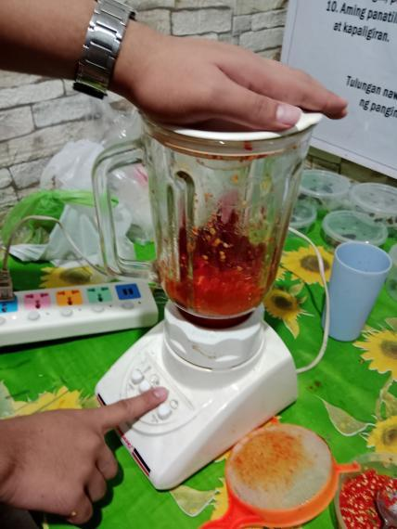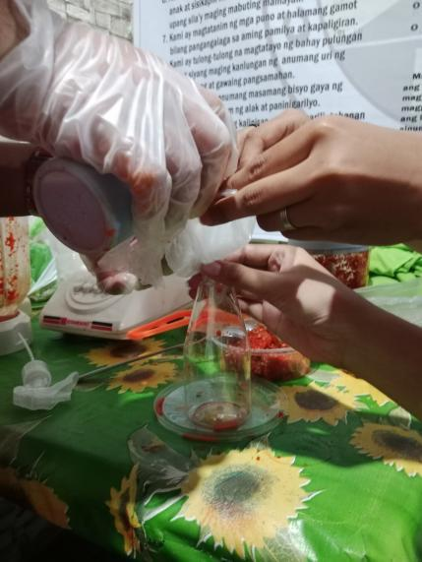

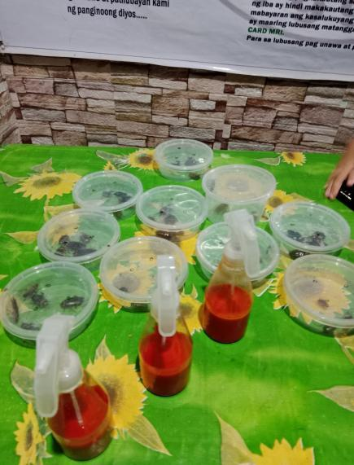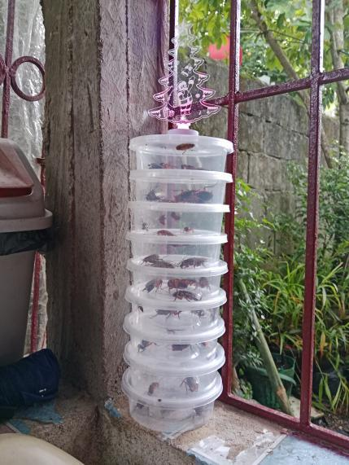



**APPENDIX F**

**CURRICULUM VITAE**

**AIRA D. MORILLO**

Zone 3, South Aurora, Sipocot Camarines Sur 4408

Contact No: 09123456780

Email: [airamorillo20@gmail.com](mailto:airamorillo20@gmail.com)

Facebook: AIRA MORILLO

| **OBJECTIVE:**  Research aims to discover new knowledge and solve existing problems. In addition, it allows for deep exploration of specific topics, expanding knowledge and developing the ability to analyze information critically and form informed opinions. |
| --- |
| **PERSONAL BACKGROUND:**  **Date of Birth: March 20, 2007**  **Age: 17**  **Religion: Roman Catholic**  **Civil Status: Single**  **Gender: Female**  **Citizenship: Filipino**  **Languages: Bikol/Tagalog/English**  **Height: 156 cm**  **Weight: 53 kg**  **Hair Color: Black**  **Father’s Name: Agapito A. Morillo Jr.**  **Mother’s Name: Mary Jane D. Morillo** |
| **EDUCATIONAL ATTAINMENT:**  **Secondary: SIPOCOT NATIONAL HIGH SCHOOL**  **TARA, SIPOCOT, CAMARINES SUR**  **2023**  **Elementary: COMPRA ELEMENTARY SCHOOL**  **COMPRA, TINALMUD, PASACAO, CAMARINES SUR**  **2019** |
| **STRENGTH AND QUALIFICATION:**  **Strength:**   * **Focus on achievements and overcoming challenges**   **Qualification:**   * **Attended King Thomas Learning Academy Incorporated Orsem (2023)** * **Elementary | Compra Elementary School | 2018- 2019**   **-Graduated as Class Valedictorian**   * **Junior High School | Sipocot National High School | July 2023** * **-Graduated with High Honors** |
| **RESEARCH UNDERTAKEN:**   * SOCIOPOLITICAL CRITICISM: LADY GAGA'S BORN THIS WAY * EVALUATION OF ORGANIC INSECTICIDES DERIVED FROM CHILI PEPPERS *(Capsicum frutescens)* FOR COCKROACH CONTROL: FORMULATION AND EFFICACY |
| **CHARACTER REFERENCES:**  **Rhajean R. Buenaventura**  **Grade 12 - Adviser**  **09994469069**  **Jahziel A. Maala**  **Grade 11 - Adviser** |

**LAWRENCE C. SULIT**

Zone 3. Azucena, Sipocot, Camarines Sur 4408

Contact No.: 09636743996

Email: [lawrencesulit14@gmail.com](mailto:lawrencesulit14@gmail.com)

Facebook: Sulit Lawrence

| **OBJECTIVE:**  Delving into deeper knowledge of a research topic provides insight into what more can be offered and addressed. For those who are not familiar with their topic, research is a process that helps create a unique perspective and understanding. No one is perfect, and there is always room to learn; new insights and discoveries can be made in any field. |
| --- |
| **PERSONAL BACKGROUND:**  **Date of Birth: March 4, 2007**  **Age: 17**  **Religion: Roman Catholic**  **Civil Status: Single**  **Gender: Male**  **Citizenship: Filipino**  **Languages: Bikol/Tagalog/English**  **Height: 165 cm**  **Weight: 92kg**  **Hair Color: Black**  **Father’s Name: Mario Q. Sulit**  **Mother’s Name: Lorna B. Cortezano** |
| **EDUCATIONAL ATTAINMENT:**  **Secondary: SIPOCOT NATIONAL HIGH SCHOOL**  **TARA, SIPOCOT, CAMARINES SUR**  **2023**  **Elementary: SIPOCOT NORTH CENTRAL SCHOOL**  **IMPIG, SIPOCOT, CAMARINES SUR**  **2019** |
| **STRENGTH AND QUALIFICATION:**   * **Creativity** * **Adaptability** * **Analyzation Skills** * **Computer Literate** |
| **RESEARCH UNDERTAKEN:**   * SOCIOPOLITICAL CRITICISM: LADY GAGA'S BORN THIS WAY * EVALUATION OF ORGANIC INSECTICIDES DERIVED FROM CHILI PEPPERS *(Capsicum frutescens)* FOR COCKROACH CONTROL: FORMULATION AND EFFICACY |
| **CHARACTER REFERENCES:**  **Rhajean R. Buenaventura**  **Grade 12 - Adviser**  **09994469069**  **Jahziel A. Maala**  **Grade 11 - Adviser** |

**CRISTAL ANN V. PACON**

Zone 7. Tumanan, Libmanan, Camarines Sur 4407

Contact No.: 09944361823

Email: [paconcristal@gmail.com](mailto:paconcristal@gmail.com)

Facebook: Cristal V. Pacon

| **OBJECTIVE:**  As a student, it increases my comprehension while improving my critical thinking and problem-solving abilities. It enables me to discover unbiased data, relate theory to actual uses, and offer useful answers to problems. Additionally, research develops curiosity, and decision-making which helps me to grow as an individual and make a meaningful impact in what I do. |
| --- |
| **PERSONAL BACKGROUND:**  **Date of Birth: October 7, 2007**  **Age: 17**  **Religion: Roman Catholic**  **Civil Status: Single**  **Gender: Female**  **Citizenship: Filipino**  **Languages: Bikol/Tagalog/English**  **Height: 5’0**  **Weight: 47kg**  **Hair Color: Black**  **Father’s Name: N/A**  **Mother’s Name: Enelita V. Pacon** |
| **EDUCATIONAL ATTAINMENT:**  **Secondary: KING THOMAS LEARNING ACADEMY, INC.**  **MALUBAGO, SIPOCOT, CAMARINES SUR**  **2023**  **Elementary: TARA ELEMENTARY SCHOOL**  **TARA, SIPOCOT, CAMARINES SUR**  **2019** |
| **STRENGTH AND QUALIFICATION:**   * **Optimistic, active listening** * **Critical thinking** |
| **RESEARCH UNDERTAKEN:**   * EFFECTS OF LIMITED INTERNET CONNECTION TO THE ACADEMIC PERFORMANCE OF STUDENTS IN KING THOMAS LEARNING ACADEMY PREMICESE * FEMINISM CRITICAL APPROACH: TAYLOR SWIFT'S THE MAN * EVALUATION OF ORGANIC INSECTICIDES DERIVED FROM CHILI PEPPERS *(Capsicum frutescens)* FOR COCKROACH CONTROL: FORMULATION AND EFFICACY |
| **CHARACTER REFERENCES:**  **Rhajean R. Buenaventura**  **Grade 12 - Adviser**  **09994469069** |

**BIANCA HAZEL M. DELOS SANTOS**

Puro 1. Barcelonita, Cabusao, Camarines Sur

Contact No.: 09947546988

Email: [biancahazelmdelossantos@gmail.com](mailto:biancahazelmdelossantos@gmail.com)

Facebook: Bianca Hazel Delos Santos

| **OBJECTIVE:**  Research is about exploring new ideas and widening our knowledge. As a student and individual, research is essential to my academic growth and development. It enhances my comprehension, knowledge, and ability to study new things. Additionally, it helps me improve and makes me a better learner, and I might even be able to help others in the future. |
| --- |
| **PERSONAL BACKGROUND:**  **Date of Birth: October 23, 2007**  **Age: 17**  **Religion: Roman Catholic**  **Civil Status: Single**  **Gender: Female**  **Citizenship: Filipino**  **Languages: Bikol/Tagalog/English**  **Height: 5'3**  **Weight: 48kg**  **Hair Color: Black**  **Father’s Name: Hector A. Delos Santos**  **Mother’s Name: Violeta M. Delos Santos** |
| **EDUCATIONAL ATTAINMENT:**  **Secondary: BARCELONITA FISHERIES SCHOOL**  **BARCELONITA, CABUSAO, CAMARINES SUR**  **2023**  **Elementary: BARCELONITA ELEMENTARY SCHOOL**  **BARCELONITA, CABUSAO, CAMARINES SUR**  **2019** |
| **STRENGTH AND QUALIFICATION:**   * **Patience and time management** * **Organizational skills** |
| **RESEARCH UNDERTAKEN:**   * FEMINIST APPROACH CRITICISM: JOHN MUSKER AND RON CLEMEN’S “MOANA” * EVALUATION OF ORGANIC INSECTICIDES DERIVED FROM CHILI PEPPERS *(Capsicum frutescens)* FOR COCKROACH CONTROL: FORMULATION AND EFFICACY |
| **CHARACTER REFERENCES:**  **Rhajean R. Buenaventura**  **Grade 12 - Adviser**  **09994469069** |

**JORELLE JHADE E. ESPIRITU**

Zone 3. Impig, Sipocot Camarines Sur 4408

Contact No.: 09939877221

Email: [jorellejhade16@gmail.com](mailto:jorellejhade16@gmail.com)

Facebook: Jorelle Jhade Espiritu

| **OBJECTIVE:**  As a student, it is to gain more knowledge and try new things with experimental way and observations. Knowing things around me can easily help me to adjust my behavior and to know each of us our own opinion and expectations. With the help of research, it gives us the ability to complete tasks and to solve some problems that everyone can have a difficulty to avoid. |
| --- |
| **PERSONAL BACKGROUND:**  **Date of Birth: September 16, 2007**  **Age: 17**  **Religion: Roman Catholic**  **Civil Status: Single**  **Gender: Female**  **Citizenship: Filipino**  **Languages: Bikol/Tagalog/English**  **Height: 5’0**  **Weight: 37kg**  **Hair Color: Dark Brown**  **Father’s Name: Jerome G. Espiritu**  **Mother’s Name: Doña Esperanza B. Espera** |
| **EDUCATIONAL ATTAINMENT:**  **Secondary: SIPOCOT NATIONAL HIGH SCHOOL**  **TARA, SIPOCOT, CAMARINES SUR**  **2023**  **Elementary: RICARDO P. CRUZ Sr. ELEMENTARY SCHOOL**  **NEW LOWER BICUTAN, MANUEL L. QUEZON CITY**  **2019** |
| **STRENGTH AND QUALIFICATION:**   * **Creativity, problem-solving, Emotional Intelligence** * **Time management, communication.** |
| **RESEARCH UNDERTAKEN:**   * EFFECTS OF ARTIFICIAL INTELLIGENCE ON THE WRITTEN ACTIVITIES OF STTUDENT AT KING THOMAS LEARNING ACADEMY, INC. * EVALUATION OF ORGANIC INSECTICIDES DERIVED FROM CHILI PEPPERS *(Capsicum frutescens)* FOR COCKROACH CONTROL: FORMULATION AND EFFICACY |
| **CHARACTER REFERENCES:**  **Rhajean R. Buenaventura**  **Grade 12 - Adviser**  **09994469069** |

**FRANCINE LIAN J. FRANCISCO**

Lower Santa Cruz Ragay Camarines Sur

Contact No.: 09604384077

Email: [francinelianfrancisco@gmail.com](mailto:francinelianfrancisco@gmail.com)

Facebook: Francine Francisco

| **OBJECTIVE:**  It explains the purpose of research and the ideas behind it. It enables me to explore my interests, pick up new skills and push myself in unique ways. |
| --- |
| **PERSONAL BACKGROUND:**  **Date of Birth: March 31, 2007**  **Age: 17**  **Religion: Roman Catholic**  **Civil Status: Single**  **Gender: Female**  **Citizenship: Filipino**  **Languages: Bikol/Tagalog/English**  **Height: 5’6**  **Weight: 59kg**  **Hair Color: Black**  **Father’s Name: Jovin T. Francisco**  **Mother’s Name: Lea Grace J. Francisco** |
| **EDUCATIONAL ATTAINMENT:**  **Secondary: ARBORVITAE PLAINS MONTESSORI INC.**  **PANAYTAYAN, RAGAY, CAMARINES SUR**  **2023**  **Elementary: RAGAY SENTH DAY ADVENTIST MULYIGADE SCHOOL INC.**  **LOWER SANTA CRUZ, RAGAY, CAMARINES SUR**  **2019** |
| **STRENGTH AND QUALIFICATION:**   * **Communication and creativity** * **Social Skills** |
| **RESEARCH UNDERTAKEN:**   * FEMINISM CRITICAL APPROACH: TAYLOR SWIFT’S THE MAN * EVALUATION OF ORGANIC INSECTICIDES DERIVED FROM CHILI PEPPERS *(Capsicum frutescens)* FOR COCKROACH CONTROL: FORMULATION AND EFFICACY |
| **CHARACTER REFERENCES:**  **Rhajean R. Buenaventura**  **09994469069** |